**Task 3** - Provisioning two VMs in a single vagrantfile

### Created a new folder structure

* web_server
* database_server

### Provision shell scripts

#### web_server/bootstrap.sh (nginx)

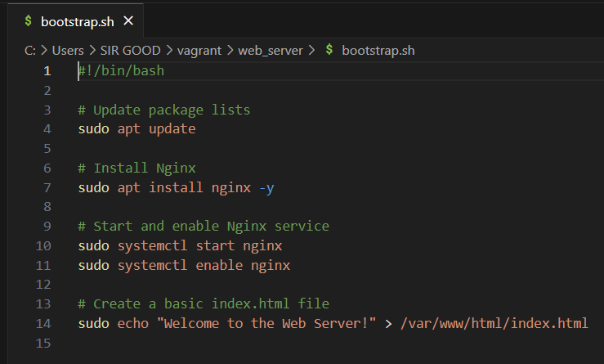

#### database_server/bootstrap.sh

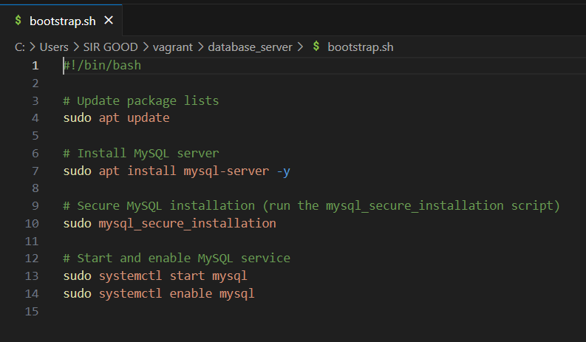

### Created a vagrantfile

#### Referenced the shell scripts using path option “web_server/bootstrap.sh” and “database_server/bootstrap.sh” respectively.

#### Customized memory = 1024 (web_server) and memory = 2048 (database_server) respectively

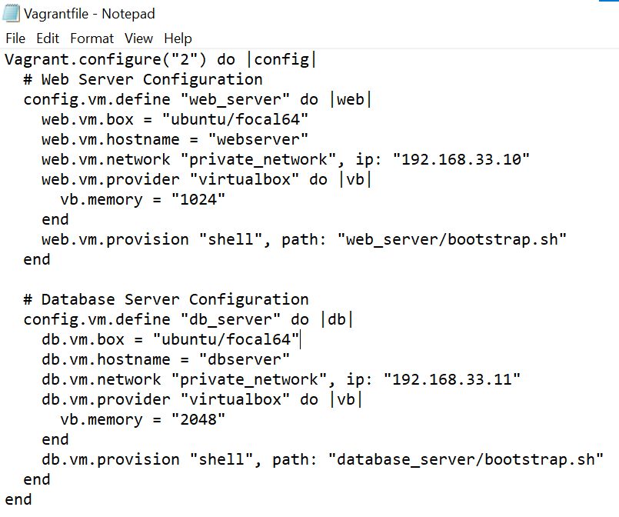

### Output screenshots

#### **vagrant status** (showing both VMs running)

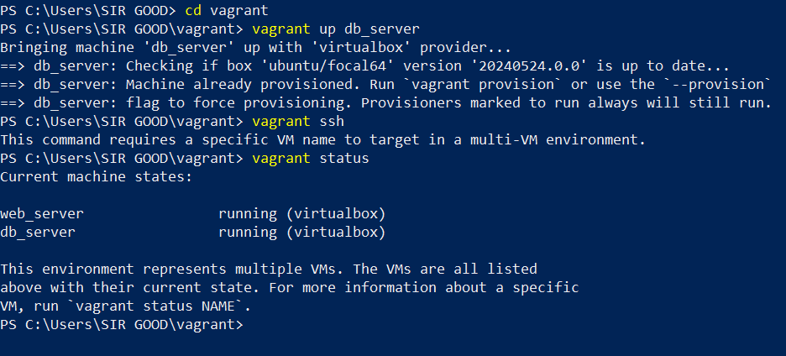

#### **vagrant ssh web_server** (logged into the web server VM)

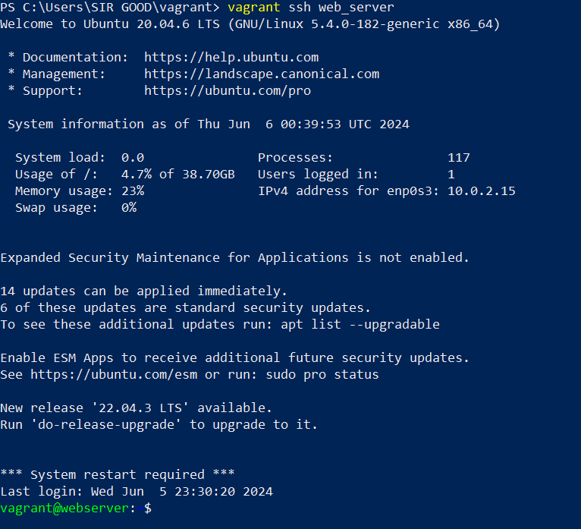

#### **sudo systemctl status nginx** (showing Nginx running on the web server)

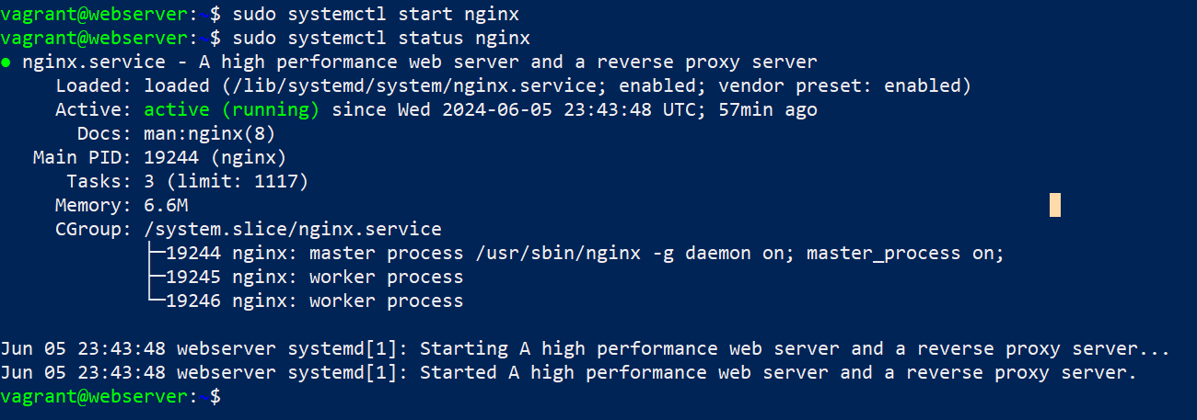

#### **vagrant ssh db_server** (logged into the database server VM)

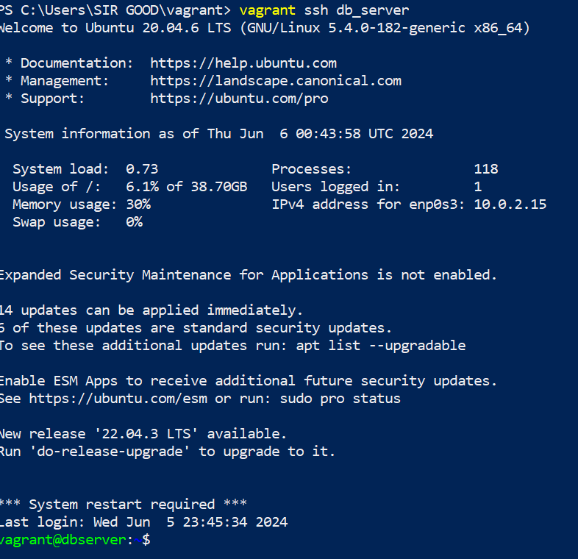

#### **sudo systemctl status mysql** (showing MySQL running on the database server)

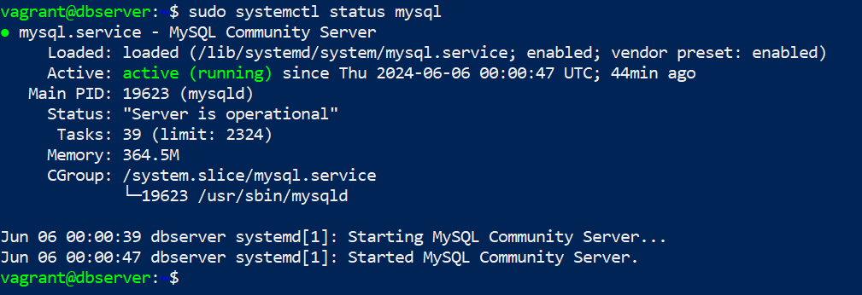

#### **Ping 192.168.33.11** (database_server)

